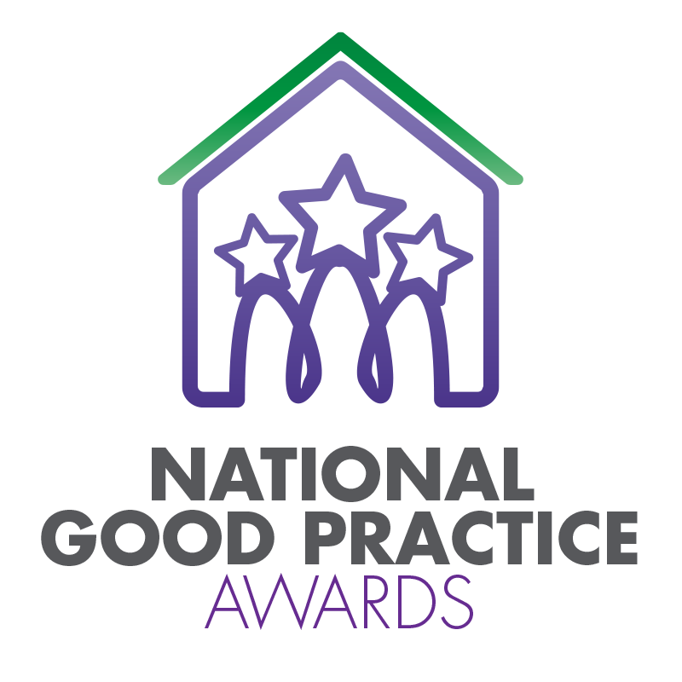
2024 TPAS Scotland Awards

Assessment Criteria and Nomination Form for:

COMMUNITIES SUPPORTING COMMUNITIES

Assessment Criteria

This award recognises and celebrates the achievements of a community led group or project that has supported other individuals or groups within their community. This support could include examples such as: running community activities; providing local facilities; environmental / gardening projects; wellbeing support; etc. If something is being done by the community for the community, we’d love to hear about it!

Judges will consider:

- The type of support provided
- How the needs of the communities/individuals were met
- The impact the support has had on individuals/communities
- Whether the projects can be sustained/adapted for the future

- Please ensure that your entry is submitted by completing this nomination form and under the headings noted. The headings are the criteria which the judges will use.
- Focus on the facts – we don’t need lengthy text, detailed bullet points are fine
- Feel free to include supporting information e.g. share links to publications, flyers, websites etc
- Please include at least one photo/image/screenshot.
- Please also see Guidance Booklet for tips and conditions of entry

Interested in this category? Please complete the nomination form on the next page

Title of Entry:

Contact name:

Contact number:

Contact e-mail address:

The aim of the Awards is to share good practice with others. Will you be happy for us to share your contact details? Yes No

1a. The type of support provided
Type here

1b. How the needs of the communities/individuals were met
Type here

1c. The impact the support has had on individuals/communities
Type here

1d. Whether the projects can be sustained/adapted for the future
Type here

2. Any further information you would like to share, please include it here
Type here

Please complete and return by noon 6th May 2024 to enquiries@tpasscotland.org.uk
No late entries will be considered

