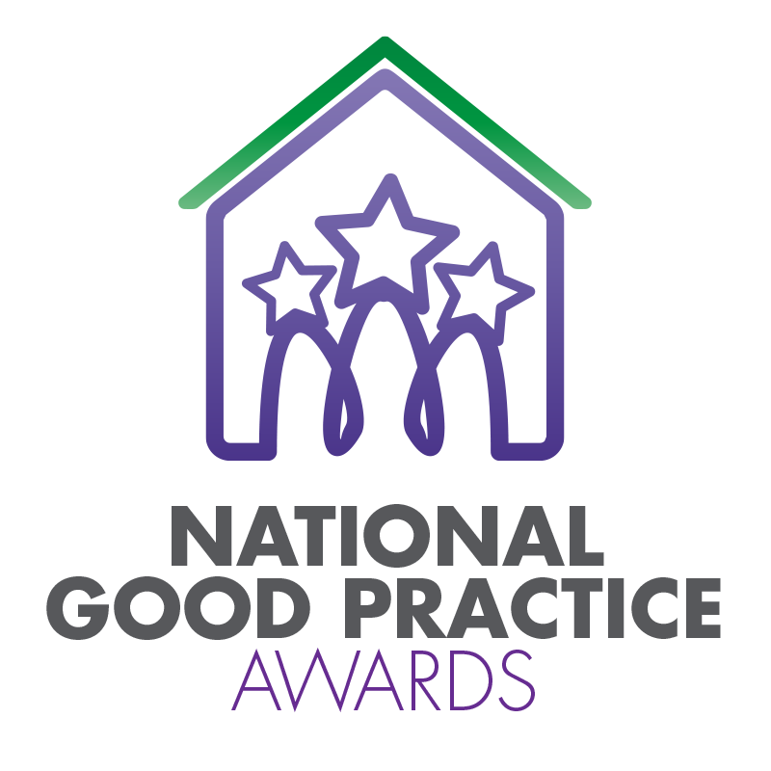
2024 TPAS Scotland Awards

Assessment Criteria and Nomination Form for:

Best practice in Widening Engagement Award

Assessment Criteria

This award will be made to an individual tenant/resident, landlord or organisation investing in and supporting tenants and communities. We are looking for support/advice programmes that are helping the wider community to overcome challenges and enhance their lives and/or enhance opportunities.

Nominations should be able to demonstrate an effective approach to support/advice. We’re looking at anything from, managing money and tackling debt to digital inclusion; warm hubs to education and employability. What we want to see is evidence of the positive impact that the programme has had on the lives of residents.

We're also interested to hear how your approach is supporting people with barriers to engagement, such as

- Physical, sight, hearing, or speech challenges,
- Mental or physical health problems
- Learning difficulties
- Being new arrivals in the community
- Barriers due to geography or facilities.

Assessment Criteria:
- Evidence of the impact and positive outcomes for tenants, residents, or communities
- Whether the support can be sustained/adapted for the future
- How the support/advice has been inclusive of those it serves.

- Please ensure that your entry is submitted by completing this nomination form and under the headings noted. The headings are the criteria which the judges will use.
- Focus on the facts – we don’t need lengthy text, detailed bullet points are fine
- Feel free to include supporting information e.g. share links to publications, flyers, websites etc
- Please include at least one photo/image/screenshot.
- Please also see Guidance Booklet for tips and conditions of entry

Interested in this category? Please complete the nomination form on the next page

Title of Entry:

Contact name:

Contact number:

Contact e-mail address:

The aim of the Awards is to share good practice with others. Will you be happy for us to share your contact details? Yes No

1a. Outline how they have made a difference to others or their community and the impact this has made
Type here

1b. What skills, commitment and energy they have shown and the impact this has had
Type here

1c. Any challenges or social barriers they may have had to overcome in helping others or their community
Type here

2. Any further information you would like to share, please include it here
Type here

Please complete and return by noon 6th May 2024 to enquiries@tpasscotland.org.uk
No late entries will be considered

